AI ASSISTIVE SMART CANE: ESP32-BASED SENSOR INTEGRATION & SYSTEM VERIFICATION

ABSTRACT
Modern assistive technologies can improve mobility by helping visually impaired individuals identify hazards around them. This report describes the hardware design, programming approach, and prototype verification of the AI Assistive Smart Cane. The system is built around an ESP32 microcontroller and combines an ultrasonic sensor for forward obstacle detection with a water sensor for detecting wet or liquid hazards near the cane tip. A rechargeable battery provides power to the system. The ESP32 repeatedly reads the sensor inputs and uses the programmed logic to support timely user feedback. The report also outlines component connections, execution flow, and test cases used to assess the integrated prototype. The design emphasizes affordable components, clear feedback, and a compact arrangement that can be developed further through additional calibration and longer-duration field testing.

I. INTRODUCTION
Reliable mobility aids are important for people with visual impairments. A traditional white cane provides valuable physical feedback, but its effectiveness can be extended by adding electronic sensing. The AI Assistive Smart Cane uses embedded hardware to translate information about nearby obstacles and ground-level liquid hazards into alerts that a user can recognize while walking. Its objective is to supplement, rather than replace, the user's established mobility practices.
The prototype combines an ESP32 controller, a forward-facing ultrasonic sensor, a water sensor positioned near the lower part of the cane, and a rechargeable battery. The controller polls the sensors and applies the programmed logic. The flowchart illustrates the repeated sensing cycle: the system checks for a hazard and, when one is detected, triggers audio or haptic feedback. If no hazard is detected, it continues scanning. This simple loop keeps the system focused on environmental monitoring and responsive feedback.
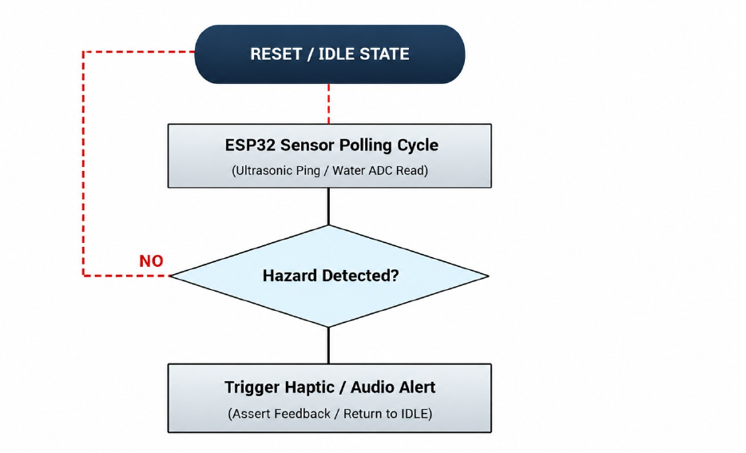
Fig. 1. Operational flowchart of the unified AI Assistive Smart Cane system.

II. SYSTEM ARCHITECTURE AND EXECUTION FLOW
The hardware is organized around the ESP32 microcontroller, which coordinates sensor inputs and user alerts. The ultrasonic sensor monitors the space in front of the cane by measuring the time taken for an emitted sound pulse to return after reflection from an obstacle. The water sensor checks for liquid or wet-surface conditions near the cane tip. These sensors provide different types of environmental information, allowing the device to monitor both forward obstacles and possible ground-level hazards.
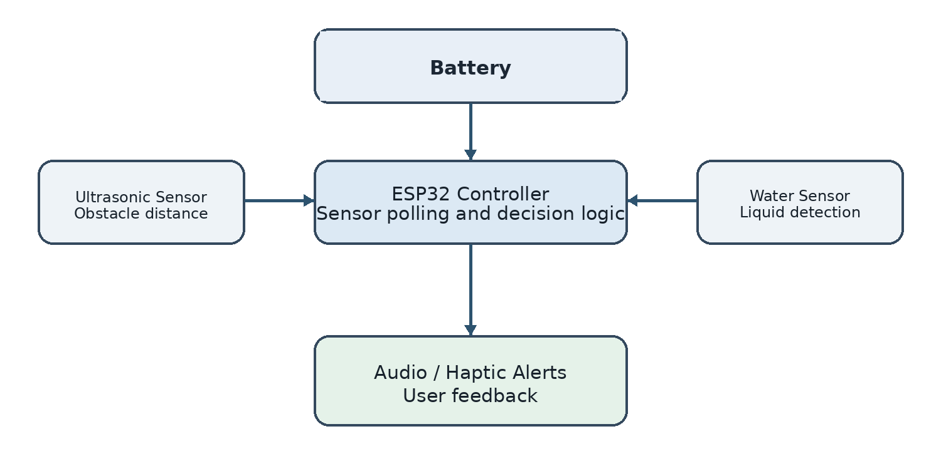
Fig. 2. Simplified system architecture showing sensor inputs, the ESP32 controller, battery power supply, and user alerts.
The rechargeable battery supplies power to the ESP32 controller and the connected sensors. The controller repeatedly reads sensor values, evaluates them using the embedded program, and initiates the appropriate feedback path. The modular arrangement also makes it possible to test the sensors, battery-powered operation, and alert outputs separately before evaluating the complete cane.
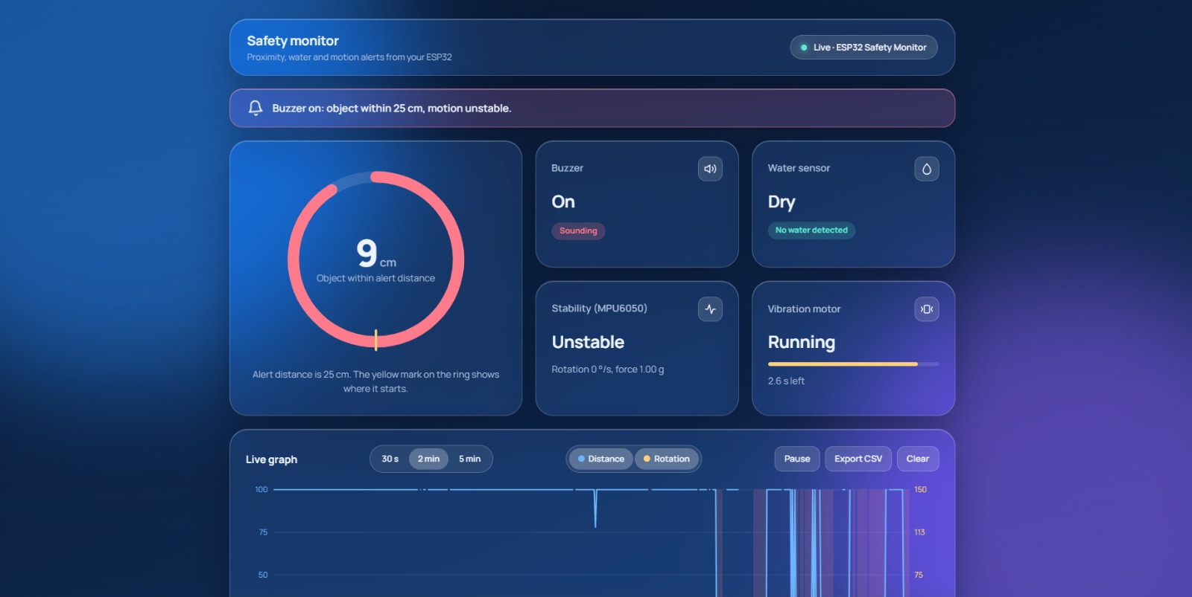
Fig. 3. Live safety-monitor dashboard showing distance, water, motion, buzzer, and vibration readings.
The console output records ESP32 initialization, a battery reading, and sensor pin mapping. It also shows sample distance and moisture readings during the polling loop. These entries illustrate the intended sequence of startup, peripheral initialization, and repeated sensor acquisition.
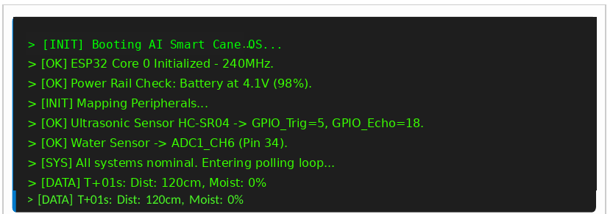
Fig. 4. Console output showing initialization, battery status, and sample sensor readings.

III. COMPONENT IMPLEMENTATION AND SYNTHESIS

A. ESP32 and Ultrasonic Sensor
The ESP32 serves as the central controller and runs the embedded C++ program. According to the source report, the ultrasonic sensor uses GPIO 5 for the trigger signal and GPIO 18 for the echo signal. The program generates a short trigger pulse, measures the returned echo timing, and estimates the distance to an obstacle from the sound-travel time. Accurate timing and suitable threshold calibration are important because unstable readings could produce delayed or unnecessary alerts.

B. Water Sensor and Analog Sampling
The water sensor is connected to the ESP32 analog input identified in the source report as ADC1_CH6 on GPIO 34. The controller samples the analog value and compares it with a configured baseline or threshold to determine whether a liquid hazard may be present. The threshold should be checked under expected operating conditions because sensor response can vary with contact, moisture, and the condition of the sensing surface.

C. Battery Power Supply
A rechargeable battery supplies power to the ESP32 controller and sensors. The operating duration depends on battery capacity, sensor activity, and the use of audio or vibration alerts. The battery should be securely mounted and its voltage should remain within the operating requirements of the connected components.

D. Embedded Execution Logic
The software repeatedly polls the sensors, evaluates their readings, and follows the decision flow shown in Fig. 1. A detected hazard leads to the programmed audio or haptic alert; otherwise, the device returns to the idle scanning cycle. A practical implementation should keep the sensor-reading routine predictable, avoid unnecessary blocking delays, and validate selected thresholds with stationary obstacles, approaching obstacles, and wet-surface tests.

IV. VERIFICATION AND SENSOR ANALYSIS
The prototype was checked through separate tests for the ultrasonic sensor, water sensor, battery-powered operation, and the integrated system. Ultrasonic testing examined echo timing against stationary and approaching obstacles. Water-sensor testing used repeated liquid-contact trials to observe the analog response. Integrated checks also considered whether simultaneous sensor polling and alert activation affected the stability of the controller or power supply.
The test counts and pass/fail values below are reproduced from the source report. They summarize the reported test outcomes; they should be supported by retained measurement logs if the report is used as formal experimental evidence.
Peripheral / Test | Test Cases | Passed | Failed
Ultrasonic sensor (echo timing) | 500 | 500 | 0
Water sensor (ADC polling) | 250 | 250 | 0
Battery load | 100 | 100 | 0
Integrated AI system | 850 | 850 | 0
The battery-powered system was also observed during feedback operation, including buzzer and motor activation. Repeating these tests over longer periods and recording battery-voltage readings would provide stronger evidence of reliability in everyday use.

V. PHYSICAL HARDWARE LAYOUT AND TESTING
After logical checks, the components were mounted on a mobility cane. The ESP32 board was housed in the grip enclosure, while the battery was placed in the handle to provide power to the system. The ultrasonic sensor was mounted facing forward at an upward angle reported as approximately 15 degrees, with the water-sensor probes positioned parallel to the cane tip. This arrangement aims to keep the sensing direction useful while leaving the handle practical to hold.
The source report lists a 2.5 cm ultrasonic minimum range, approximately 10 ms system latency, and a 24-hour battery yield as the prototype's performance metrics. These values are retained as reported figures; their practical meaning depends on the test setup, sensor calibration, alert duty cycle, and battery capacity. Additional trials across different surfaces and environmental conditions would help determine how consistently these results can be reproduced.
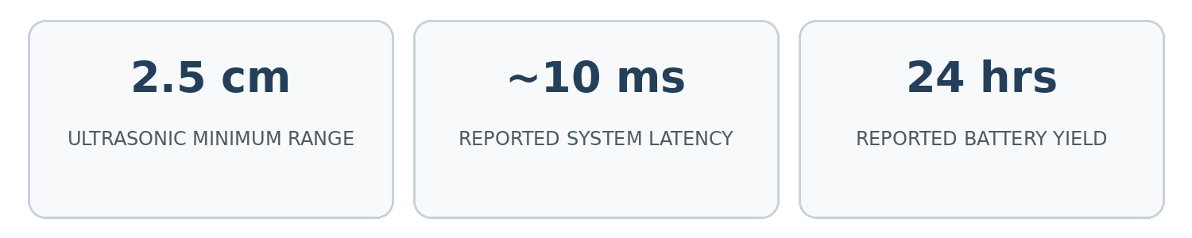
Fig. 5. Performance metrics reported in the source document.

VI. CONCLUSION AND FUTURE SCOPE
The AI Assistive Smart Cane demonstrates an embedded approach to combining obstacle sensing, liquid-hazard detection, and user alerts around an ESP32 controller. The ultrasonic sensor supplies distance information, while the water sensor contributes ground-level hazard information. A rechargeable battery powers the controller and sensing components. The test summary in the source report records successful outcomes for the listed test vectors, although further documented field trials would be needed to establish performance across a wider range of users and environments.
Future development can focus on improving enclosure protection, refining sensor thresholds, testing battery endurance under realistic use, and evaluating the device on different floor surfaces and obstacle types. The alert pattern and physical placement can also be reviewed with user feedback to ensure warnings are clear without becoming distracting. These improvements would help assess the prototype's suitability for longer-term assistive use.

REFERENCES
[1] Espressif Systems, ESP32 Series Datasheet: Hardware Specifications and Microcontroller Architecture, Version 3.4, 2023.
[2] T. Kumar and R. Desai, "Integration of Ultrasonic and Conductivity Sensors in Embedded IoT Systems," Journal of Embedded Sensors, vol. 8, pp. 44–51, 2021.
[3] IEEE Standards Association, IEEE Standard for Smart Battery Power Interfaces in Assistive Devices, IEEE Std 1625, 2020.

